Appendix S1 ODD of pi model v1.9

Differences between symmetric and asymmetric facilitation matter: exploring the interplay between modes of positive and negative plant interactions

Yue Lin*, Uta Berger, Volker Grimm and Qian-Ru Ji
* Corresponding author; yue.lin.tud@googlemail.com
Institute of Forest Growth and Computer Science, Dresden University of Technology, P.O. 1117, 01735 Tharandt, Germany

Model description

A GENERAL ONTOGENETIC GROWTH MODEL FOR PLANTS

The essential basis for modeling the ontogeny of individual plants starts with an energy conservation equation (Enquist & Niklas 2001; West et al. 2001; Hou et al. 2008):

B_{p} = B_{r} + B_{s} = B_{r} + E_{s}dm/dt (1)

where B_{p} is defined as total energy intake rate (i.e. gross photosynthetic rate). A fraction of this assimilated energy is consumed by respiration, B_{r}, the remainder is stored as reserves and used for synthesizing new tissues, B_{s} (Figure A1). E_{s} is the metabolic energy stored in one unit of biomass and dm/dt is the change in biomass (m) per unit time (t).
The rate of energy consumed by respiration, B_{r}, depends on three major processes that require energy (Figure A1): maintenance of biomass (B_{maint}), ion transport (B_{tran}) and biosynthesis (B_{syn}), which can be summarized as (Lambers et al. 2008):

B_{r} = B_{maint} + B_{tran} + B_{syn} = ∑B_{m}m_{living} + B_{tran} + E_{c}dm/dt (2)

where B_{m} denotes average mass-specific maintenance metabolic rate, m_{living} stands for the biomass of living tissues, and E_{c} designates the energy required to synthesize a unit of biomass.
Typical average biological parameters of plant cells (tissue) are taken as a fundamental unit here, and possible differences between tissues are ignored (West et al. 2001). Note that the terms B_{s}=E_{s}dm/dt in Eqn (1) and B_{syn}=E_{c}dm/dt in Eqn (2) are quite different: S stands for the rate of cumulative energy content of new biomass, whereas B_{syn} refers to the metabolic energy expended on biosynthesis which is dissipated as heat instead of obtained as stored biomass (Hou et al. 2008). Combining Eqns (1) and (2), we get

B_{p} = B_{maint} + B_{tran} + B_{syn} + B_{s} = ∑B_{m}m_{living} + B_{tran} + E₀dm/dt (3)

where E₀ = E_{c}+E_{s}, is constant for a given taxon and stands for the sum of energy stored in a unit of biomass plus the energy used to synthesize this biomass, i.e. the synthesis costs of a unit of biomass.
Equation (3) is quite general, but B_{maint} may vary between woody and non-woody plants, as woody plants contain nonliving tissues (e.g. heartwood in stem and root) which do not need energy for their maintenance (Enquist et al. 2009). Also large trees with a large amount of heartwood, contain much less living tissues (m_{living}) in comparison to the total biomass (m). We assume that during ontogeny, woody plants mainly expend energy for maintaining their photosynthetic tissues (leaves), m_{L}, and conducting tissues (standing sapwood of stem and root), m_{C}, and suppose

B_{maint} = ∑B_{m}m_{living} = B_{m}m_{L} + B_{m}m_{C} = B_{L} + B_{C} (4)

for woody plants, where B_{L} and B_{C} specify the metabolic rate for maintaining photosynthetic and conducting tissues, respectively (Figure A1). Combining Eqns (3) and (4) we can get the energy conservation equation for woody plants:

B_{p} = B_{m}m_{L} + B_{m}m_{C} + B_{tran} + E₀ dm/dt (5)

Based on empirical measurements and theoretical assumptions linking biomass and metabolism, MST (West et al. 1999; Enquist 2002; Price et al. 2007; Enquist et al. 2009; West et al. 2009) predicts that whole-plant, or gross, photosynthesis rate, B_{p}, and ion transport metabolic rate B_{tran} allometrically scale with the total biomass of a plant, m, as B_{p}∝B_{tran}∝m^{θ}, where θ ≡ 1/(2α+β) and α and β representing the geometry and biomechanics of the vascular network. Their values may vary across different taxa (Price et al. 2007).
Although the Eqn (5) can be easily recast by using empirical values of α and β, we use α = 1/2 and β = 1/3 as common and idealized cases here (Price et al. 2007; West et al. 2009), so that θ = 3/4. Models based on these scaling relationships predict that the standing leaf biomass, m_{L}, scales with respect to total biomass as m_{L}∝m^{~3/4} across woody plants which was confirmed by empirical data (Sack et al. 2002; Niklas 2005).
The relationship between standing sapwood biomass (m_{C}) and total biomass m is largely unknown, therefore here we assume that the tissue- or species-specific wood density of conducting tissues, d_{C}, is constant for a given plant. Its total volume of conducting tissues, v_{C}, can be formulated as v_{C}∝A_{S}h, where A_{S} is the mean cross-sectional area of sapwood and h is the height of plant. Because A_{S}∝m^{3/4} and h∝m^{1/4} (Enquist 2002; Savage et al. 2010), we therefore derive the allometric relationship m_{C}=d_{C}v_{C}∝A_{S}h∝m^{3/4}m^{1/4}∝m for woody plants. Substituting the allometric relationship on biomass for all related terms in Eqn (5) gives

B₀m^{3/4} = B_{m}a_{L}m^{3/4} + B_{m}a_{S}m + a_{tran}m^{3/4} + E₀ dm/dt (6)

where B_{p}=B₀m^{3/4} reflects the total energy intake rate (i.e. gross photosynthetic rate) under optimal situation, B₀ is constant for a given taxon (West et al. 1999), a_{L}, a_{S} and a_{tran} are normalization constants. Eqn (6) can therefore be rewritten as

dm/dt = a₁m^{3/4} – b₁m = a₁m^{3/4} [ 1 – ( m / M₁)^{1/4} ] (7)

with a₁ = (B₀ – B_{m}a_{L}– a_{tran})/E₀ and b₁ = B_{m}a_{S}/E₀. The value M₁ = (a₁/b₁)⁴ is asymptotic maximum body size of the woody plant (calculated for dm/dt = 0), which depends on species-specific traits and is determined by the systematic variation of the in vivo metabolic rate within different taxa (West et al. 2001). The gain term (a₁m^{3/4}) in Eqn (7) dominates while plants grow to a moderate size, which has been shown to be a good quantitative description of plant growth (Niklas & Enquist 2001; Enquist et al. 2009).
Across non-woody plants which lack secondary tissues (or juveniles of woody plant which have not accumulated much secondary tissue), the total biomass of living tissues (as leaves, m_{L}, stem, m_{S}, and roots, m_{R} is approximately equal to the whole plant mass, m_{living} = m_{L} + m_{S} + m_{R} ≈ m (Enquist 2002). Combining Eqn (3) with those scaling relationship leads to

B₀m^{3/4} = B_{m}m + a_{tran}m + E₀ dm/dt (8)

for non-woody plants.
Taking the parameters in Eqn (8) in the same sense as before, Eqn (8) can be re-expressed as

dm/dt = a₂m^{3/4} – b₂m = a₂m^{3/4} [ 1 – ( m / M₂)^{1/4} ] (9)

with a₂ = B₀/E₀, b₂ = (B_{m}+a_{tran})/E, and M₂ = (a₂/b₂)⁴, which is the asymptotic maximum body size of a non-woody plant.
Eqns (7) and (9) have same form, and we use a general form of the growth function for both woody and non-woody plants:

dm/dt = am^{3/4} – bm = am^{3/4} [ 1 – ( m / M₀)^{1/4} ] (10)

where a is a general constant and M₀ is the generally asymptotic maximum body size of plant.

PLANT GROWTH UNDER ABIOTIC STRESS

Because ‘stress’ is not a precise concept, the characteristics of abiotic stress factors are different and can be resource-independent or dependent (Maestre et al. 2009). We assume simply that abiotic stress factors act in two ways: restricting the energy intake rate or burdening the maintenance of plant or even concurrently, this is presumably always true for plants (Lambers et al. 2008). Since the plant growth rate is negatively and linearly related to the degree of abiotic stress (Travis et al. 2006; Chu et al. 2008, 2009), incorporating abiotic stress in Eqn (10), we have

dm/dt = am^{3/4} – bm – Sam^{3/4} = (1 – S)am^{3/4} [ 1 – ( m / M_{s})^{1/4} ] (11)

where S is a dimensionless efficiency factor that indicates the level of stress ranges from 0 (no stress) to 1 (extreme stress), Sam^{3/4} is the energy restricted or burdened by abiotic stress which is proportional to total energy intake rate and increasing with the degree of stress level, and M_{s}=(1–S)⁴M₀ is the maximum achievable biomass of plant under stress.

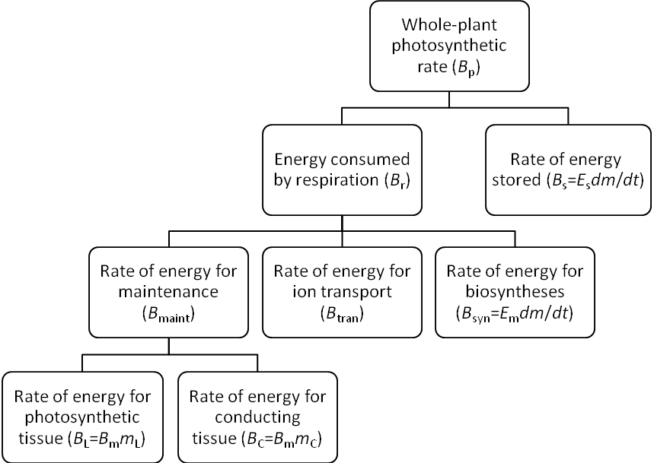

Figure A1. Assimilated energy partition of plants during ontogenetic growth.

INDIVIDUAL-BASED MODEL (IBM) CONSIDERING MODE OF COMPETITION, FACILITATION, ABIOTIC STRESS AND ONTOGENETIC GROWTH

The following model description follows the ODD protocol (Overview, Design concepts, Details) for describing individual- and agent-based models (Grimm et al. 2006; Grimm et al. 2010),

Purpose
The aim of this model is to evaluate the multiple effects of the modes of competition and facilitation under abiotic stress on regulating plant population dynamics, specifically on spatial pattern formation induced by density-dependent mortality. In particular, we test whether different modes of facilitations at individual plant level can result in the spatial aggregation of the population. The model does not represent specific species, but generic ones.

Entities, state variables, and scales
The entities in the model are plants and square habitat units, or patches (Table A1). Plants are characterized by the following state variables: initial growth rate, initial biomass, maximum biomass (asymptotic biomass), current biomass and their position, i.e. coordinates of the stem. Each individual plant has its own circular zone-of-influence (ZOI). The ZOI stands for the physical space occupied by a plant, and represents the energy and resources potentially available to this plant, which is allometrically related to its body mass. Neighboring plants only compete for the resources when their ZOIs are overlapping.
In order to make the spatial calculations of resource competition easier, ZOIs are projected onto a grid of patches. To avoid edge effects, we use a torus world with a size of 200 × 200 patches (Grimm & Railsback 2005). Each patch represents 1 m² or 1 cm² for woody- and non-woody plants, respectively. The state of each patch is characterized by its resource availability. We use a homogeneous environment here as all patches have the same, and constant, degree of abiotic stress. One time step in the model represents approximately one year for woody plants and one day for non-woody plants.

Table A1. State variables and initialization in the individual-based model. Actual values are drawn from the given intervals to introduce a certain degree of heterogeneity among individuals.

Variable | Description | Initial Value [unit] (woody/non-woody)
Plants
c | Initial growth rate | 1 ± 0.1 [kg m⁻² time step⁻¹] / [mg cm⁻² time step⁻¹]
m₀ | Initial body mass | 2 ± 0.2 [kg] / [mg]
M₀ | Maximal biomass | 2×10⁶ ± 2×10⁵ [kg] / [mg]
m | Current biomass | [kg] / [mg]
A | Zone of influence | [m⁻²] / [cm⁻²]
Patches
S | Abiotic stress level | [0, 1]
Initialization
Mortality | Threshold of death | 5% of m^{3/4}
Density | Number of plants | 300 [ha⁻¹] / [m⁻²]
Random seed | Generation of random number | 123456789
(Aggregation) | Number of cohort | 6 (50 individuals / cohort)
(Aggregation) | Cluster scale (diameter) | 50% of the world size

Process overview and scheduling
After initialization, all individual plants with a given density are randomly distributed in the world. The processes of local competition, facilitation, growth and mortality of each plant are fulfilled within each time step. In each step, individual plants first sense the environment qualities of patches within their ZOIs, the area (radius) of an individual plant’s ZOI is determined by its current biomass. When their ZOIs are overlapping, individuals compete and facilitate within the overlapping area. Thus, the overlapping area reflecting resources is divided according to the mode of competition. At the same time, under abiotic stress in the presence of facilitation, the overlapping area reflecting the ameliorated habitat by neighbours is also divided according to the mode of facilitation. Considering the outcome of the interaction process, all individual plants grow according to the growth function. Plants with growth rates falling below a threshold die and are removed immediately. The state variables of the plants are synchronously updated within the subroutines, i.e. changes to state variables are updated only after all individuals have been processed (Grimm & Railsback 2005).

Design concepts
Basic principles: From “Metabolic Scaling Theory”, we derived a general ontogenetic growth model for individual plants. We combine this model, via the ZOI approach, with the effects of different modes of competition and facilitation under abiotic stress.
Emergence: All features observed at the population level, e.g. mass-density relationship or self-thinning trajectories (i.e. size distribution and spatial distribution, respectively), population size inequality and spatial pattern, are emerged from local interactions among plants under abiotic stress of their environment.
Interaction: Individual plants interact via competition for resources and facilitation from neighbours in the overlapping area of their ZOIs.
Stochasticity: Initial growth rate, initial biomass, maximum biomass and initial position of plants are randomly taken from the intervals given in Table 1. This introduces a certain level of heterogeneity among individual characteristics to take into account that real plants are never exactly identical.
Observation: Spatial point patterns of plants, population size, biomass of each plant, and mean biomass of all living plants are the main observations.

Initialization
If the initial spatial pattern is aggregation, we randomly choose several patches (determined by the number of cohorts) as centers and to transplant groups of individual plants (initial density / number of cohorts) among the centers within a certain cluster diameter. In the case of randomness, individual plants are randomly distributed according to the chosen initial density. Resources and abiotic stress are spatially and temporally constant. Each plant has an initial biomass (m₀), maximal biomass (M₀) and initial growth rate (c) drawn from truncated normal distributions with average and intervals given in Table A1.

Input
After initialization, the model does not include any external inputs, i.e. the abiotic environment is constant.

Submodels
Plant growth
In our individual-based model the plant’s ZOI stands for the physical space occupied by a plant and represents the energy and resources potentially available to this plant. This space is allometrically related to the plant’s body mass, m, as c₀A=m^{3/4} (Enquist & Niklas 2001), where c₀ is a normalization constant. Accordingly, Eqn (10) can be rewritten as

dm/dt = cA [ 1 – ( m / M₀)^{1/4} ] (12)

and with abiotic stress, it becomes

dm/dt = (1 – S) cA [ 1 – ( m / M_{s})^{1/4} ] (13)

where c = ac₀, is the initial growth rates in units of mass per area and time interval. For simplicity, we choose c = 1 ± 0.1 in our model. In addition, we simulate the model with different c values. As expected, the results from different values were qualitatively similar (consist with our findings).

Competition and facilitation under abiotic stress
Competition and facilitation are incorporated by using dimensionless factors or indexes, f_{p} and f_{q} respectively. With the above assumptions, equation (12) becomes:

dm/dt = f_{p}f_{q}cA[ 1 – ( m / M)^{1/4} ] (14)

where M = (f_{p}f_{q})⁴M₀ is the maximum achievable biomass under stress with competition and facilitation.
As for competition, the modes of resource-mediated competition among plants can be located somewhere along a continuum between completely asymmetric competition (largest plants obtain all the contested resources) and completely symmetric competition (resource uptake is equal for all plants, independent of their relative sizes; Schwinning & Weiner 1998). To represent different modes of competition explicitly, we describe the competitive index f_{p} as

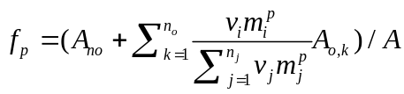 (15)

This factor thus refers to the fraction of resources available in the area which plant i could obtain after a loss of potential resources due to areas overlapped by neighbours of sizes m_{j} (Schwinning and Weiner 1998). A_{no} is the area not overlapping with neighbors, A_{o,k} denotes the n_{o} areas overlapping with n_{j} different neighbors. Parameter p determines the mode of competition, ranging from complete symmetry (p = 0) to complete asymmetry (p approaching infinity; for details and examples see Figure A2). In this research, we restrict ourselves to intraspecific facilitation and competition, and assume therefore the species-specific weighting constant of competition v_{i} and v_{j} equal 1 here, as conspecific case.
Simultaneously, assuming the effect of facilitation is additive (Molofsky 2001; Molofsky & Bever 2002; Chu et al. 2008, 2009), we define the effect of different modes of facilitation, f_{q}, as

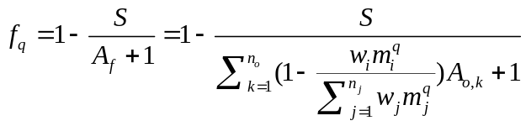 (16)

This factor is based on SGH, which reflects the facilitative effect of relieving stress and is consist with other model (Chu et al. 2008, 2009, 2010; Jia et al. 2011; for details and examples see Figure A2). To keep things simple, we follow the assumption of Chu et al. (2008, 2009) that the ZOI, A, is the same for competition and facilitation (they could be different). Where A_{f} refers to the benefit gained by plant from all interactive neighbors, and is calculated as the sum of the areas (ZOIs) overlapped with neighbour plants. The index q determines the mode of facilitation among plants, ranging from complete symmetry (q = 0, algorithmic equivalent to the form used in Chu et al. 2008; 2009) to complete asymmetry (q approaching infinity; see Table 1 for the complete form and definitions). Since we investigate the monopopulation here, to simplify, we assume the species-specific weighting constant w equals 1 here as the conspecific case, so the facilitation is size dependent. When there is no facilitation (A_{f} =0), Eqn (16) becomes 1–S, which reflects the effect of abiotic stress.

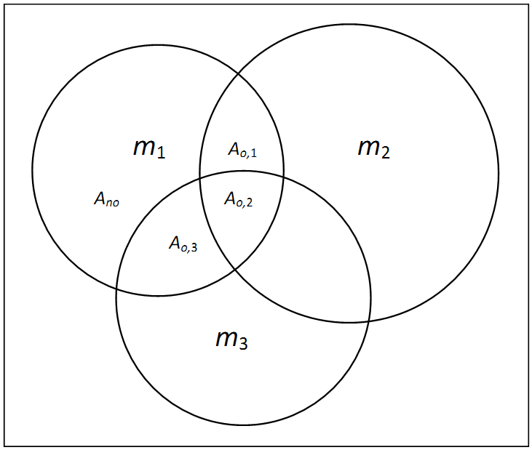

Figure A2. An example of calculating the interactive indexes (Eqns 15 and 16) with different modes of competition and facilitation by dividing plants’ ZOI (zone-of-influence). Three plants with sizes m₁, m₂ and m₃ are interacting in this example. For plant 1, its ZOI (A) was divided into four parts: A_{no}, the area not overlapping with the other two plants; A_{o,1}, the area overlapping with plant 2; A_{o,2}, the area overlapping with plants 2 and 3; A_{o,3}, the area overlapping with plant 3.
Then the actual area that plant 1 can take from A_{o,1} is
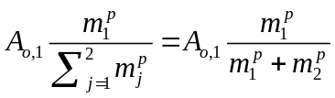
For A_{o,2},
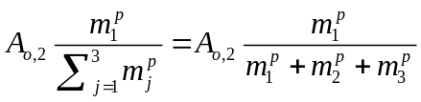
And for A_{o,3},
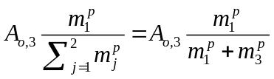
therefore, the competitive index for plant 1 is:
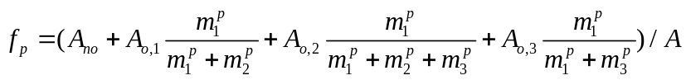
Where 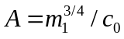. For plant 1, the benefit received from neighbours is
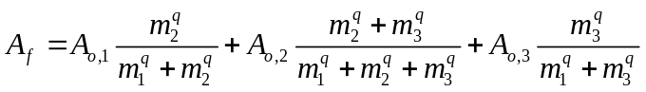
and the facilitative index for plant 1 under abiotic stress is:
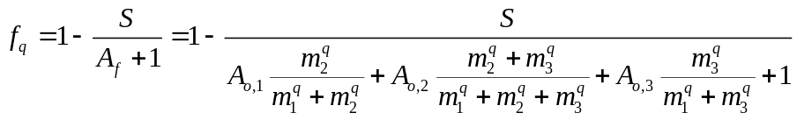
In total, Eqn (14) clearly shows how a plant’s growth rate is jointly determined by abiotic stress, S, competition, f_{p}, and facilitation f_{q}. This also implies that a plant’s final size is usually smaller than its asymptotic maximum size (M₀) during environmental stress and local competition, but can increase by the beneficial effects of neighbour plants via the amelioration of habitat.

Mortality
An individual’s mortality rate is proportional to its mass-specific metabolism (as current total metabolic rate divide by body mass; Brown et al. 2004). Based on this, we assume that individuals die if their actual growth rate (dm/dt, realistic metabolic rate) falls below a threshold fraction of their basal metabolic rate (allometrically scaled with body mass), i.e. 5% of m^{3/4}. Therefore, individual plants may die due to metabolic inactivation driven by abiotic stress, competition, senescence (when m approaches M) or combinations thereof. This provides a more realistic representation of relevant ecological process than in previous models (Stoll et al. 2002; Chu et al. 2009, 2010; Jia et al. 2011).

References

Brown, J.H., Gillooly, J.F., Allen, A.P., Savage, V.M. & West, G.B. (2004). Toward a metabolic theory of ecology. Ecology, 85, 1771-1789.
Chu, C.J., Maestre, F.T., Xiao, S., Weiner, J., Wang, Y.S., Duan, Z.H. et al. (2008). Balance between facilitation and resource competition determines biomass–density relationships in plant populations. Ecol. Lett., 11, 1189-1197.
Chu, C.J., Weiner, J., Maestre, FT, Xiao, S., Wang, Y.S., Li, Q., Yuan, J.L., Zhao, L.Q., Ren, Z.W. and Wang, G.(2009), Positive interactions can increase size inequality in plant populations. J. Ecol., 97, 1401–1407
Chu, C.J., Weiner, J., Maestre, F.T., Wang, Y.S., Morris, C., Xiao, S. et al. (2010). Effects of positive interactions, size symmetry of competition and abiotic stress on self-thinning in simulated plant populations. Ann. Bot., 106, 647-652.
Enquist, B.J. (2002). Universal scaling in tree and vascular plant allometry: toward a general quantitative theory linking plant form and function from cells to ecosystems. Tree Physiol., 22, 1045-1064.
Enquist, B.J. & Niklas, K.J. (2001). Invariant scaling relations across tree-dominated communities. Nature, 410, 655-660.
Enquist, B.J., West, G.B. & Brown, J.H. (2009). Extensions and evaluations of a general quantitative theory of forest structure and dynamics. Proc. Natl Acad. Sci. USA., 106, 7046-7051.
Grimm, V., Berger, U., Bastiansen, F., Eliassen, S., Ginot, V., Giske, J. et al. (2006). A standard protocol for describing individual-based and agent-based models. Ecol. Model., 198, 115-126.
Grimm, V., Berger, U., DeAngelis, D.L., Polhill, J.G., Giske, J. & Railsback, S.F. (2010). The ODD protocol: A review and first update. Ecol. Model., 221, 2760-2768.
Grimm, V. & Railsback, S.F. (2005). Individual-based modeling and ecology. Princeton University Press, Princeton and Oxford.
Hou, C., Zuo, W., Moses, M.E., Woodruff, W.H., Brown, J.H. & West, G.B. (2008). Energy uptake and allocation during ontogeny. Science, 322, 736-739.
Jia, X., Dai, X.F., Shen, Z.X., Zhang, J.Y. & Wang, G.X. (2011) Facilitation can maintain clustered spatial pattern of plant populations during density-dependent mortality: insights from a zone-of-influence model. Oikos, 120, 472-480.
Lambers, H., Chapin, F.S. & Pons, T.L. (2008). Plant physiological ecology. 2nd edition. Springer Verlag, New York, pp. 134-143.
Maestre, F.T., Callaway, R.M., Valladares, F. & Lortie, C.J. (2009). Refining the stress-gradient hypothesis for competition and facilitation in plant communities. J. Ecol., 97, 199–205.
Molofsky, J. & Bever, J.D. (2002). A novel theory to explain species diversity in landscapes: positive frequency dependence and habitat suitability. Proc. R. Soc. Lond., B, Biol. Sci., 269, 2389–2393.
Molofsky, J., Bever, J.D. & Antonovics, J. (2001). Coexistence under positive frequency dependence. Proc. R. Soc. Lond., B, Biol. Sci., 2001, 268–277.
Niklas, K.J. (2005). Modelling below-and above-ground biomass for non-woody and woody plants. Ann. Bot., 95, 315-321.
Niklas, K.J. & Enquist, B.J. (2001). Invariant scaling relationships for interspecific plant biomass production rates and body size. Proc. Natl Acad. Sci. USA., 98, 2922-2927.
Price, C.A., Enquist, B.J. & Savage, V.M. (2007). A general model for allometric covariation in botanical form and function. Proc. Natl Acad. Sci. USA., 104, 13204-13209.
Sack, L., Maranon, T., Grubb, P.J., Enquist, B.J. & Niklas, K.J. (2002). Global allocation rules for patterns of biomass partitioning. Science, 296, 1923a.
Schwinning, S. & Weiner, J. (1998). Mechanisms determining the degree of size asymmetry in competition among plants. Oecologia, 113, 447-455.
Stoll, P., Weiner, J., Muller-Landau, H., Müller, E. & Hara, T. (2002). Size symmetry of competition alters biomass–density relationships. Proc. R. Soc. Lond. B: Biol. Sci., 269, 2191-2195.
Travis, J.M.J., Brooker, R.W., Clark, E.J. & Dytham, C. (2006). The distribution of positive and negative species interactions across environmental gradients on a dual-lattice model. J. Theor. Biol., 241, 896–902.
West, G.B., Brown, J.H. & Enquist, B.J. (1999). A general model for the structure and allometry of plant vascular systems. Nature, 400, 664-667.
West, G.B., Brown, J.H. & Enquist, B.J. (2001). A general model for ontogenetic growth. Nature, 413, 628-631.
West, G.B., Enquist, B.J. & Brown, J.H. (2009). A general quantitative theory of forest structure and dynamics. Proc. Natl Acad. Sci., 106, 7040-7045.

